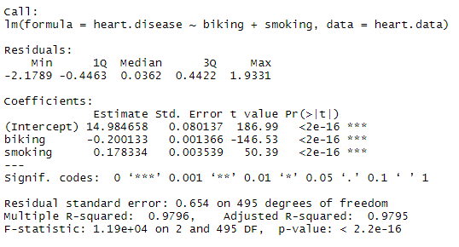

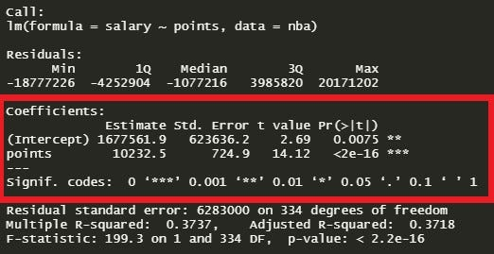

For the second Image, identify all metrics and interpret results.

How well does this model perform?

What are our X and Y?

Linear or Logistic regression? Why?